**INTRODUCTION:-**

OUR EDU- CONNECT LEARNING CENTER are student focused. Since all ESL classrooms are multi-level in some way, using learning centers allows slower students to spend more time practicing lessons from class while more advanced students deepen their understanding and ability to use the target skills or language.

Our vaishai ltd providing various services to sudents the following are the various benefits of our EDU- CONNECT learning centre.



* Practice. Students need the opportunity to practice the skills you're teaching in class. ...
* Independence. ...
* Responsibility. ...
* Learning feels like play. ...
* Opportunities for small group work. ...
* Differentiation.

***The purpose of the Edu-connect learning center***

which are also self-checking and self- selecting. The activities are used to focus on a What are learning centers? Learning centers are student centered, engaging activities set of skills and deepen the students' knowledge and abilities in that area. Students can work alone, in pairs, or in small groups.

**The concept of edu-connect learning center**

A learning center is a self-contained section of the classroom in which students engage in independent and self-directed learning activities. A learning center is a space set aside in the classroom that allows easy access to a variety of learning materials in an interesting and productive manner.

**The main Centre of learning for the child?**

According to many studies, play acts as a medium of learning for children from a very young age. It stimulates early brain development. It allows children to create and imagine, which is an important aspect of child-centered education.

## What is an Empathy Map?

An empathy map is a template that organizes a user’s behaviors and feelings to create a sense of empathy between the user and your team.

The empathy map represents a principal user and helps teams understand their motivations, concerns, and experience. Empathy mapping is a simple yet effective [workshop](https://frescopad.com/virtual-workshop-definition/) that can be conducted with various users in mind, anywhere from stakeholders, individual use cases, or entire teams of people. Many teams, such as design teams, sales, product development, and customer service, can conduct it.

Essentially, an empathy mapping exercise is a practice that seeks to get inside the head of the customer as they interact with your product/service.

While the main importance of an empathy map is creating empathy between you and the user, some other important facets of using one offer different benefits to your team. Creating an empathy map considers many factors in relation to the customer’s overall experience.

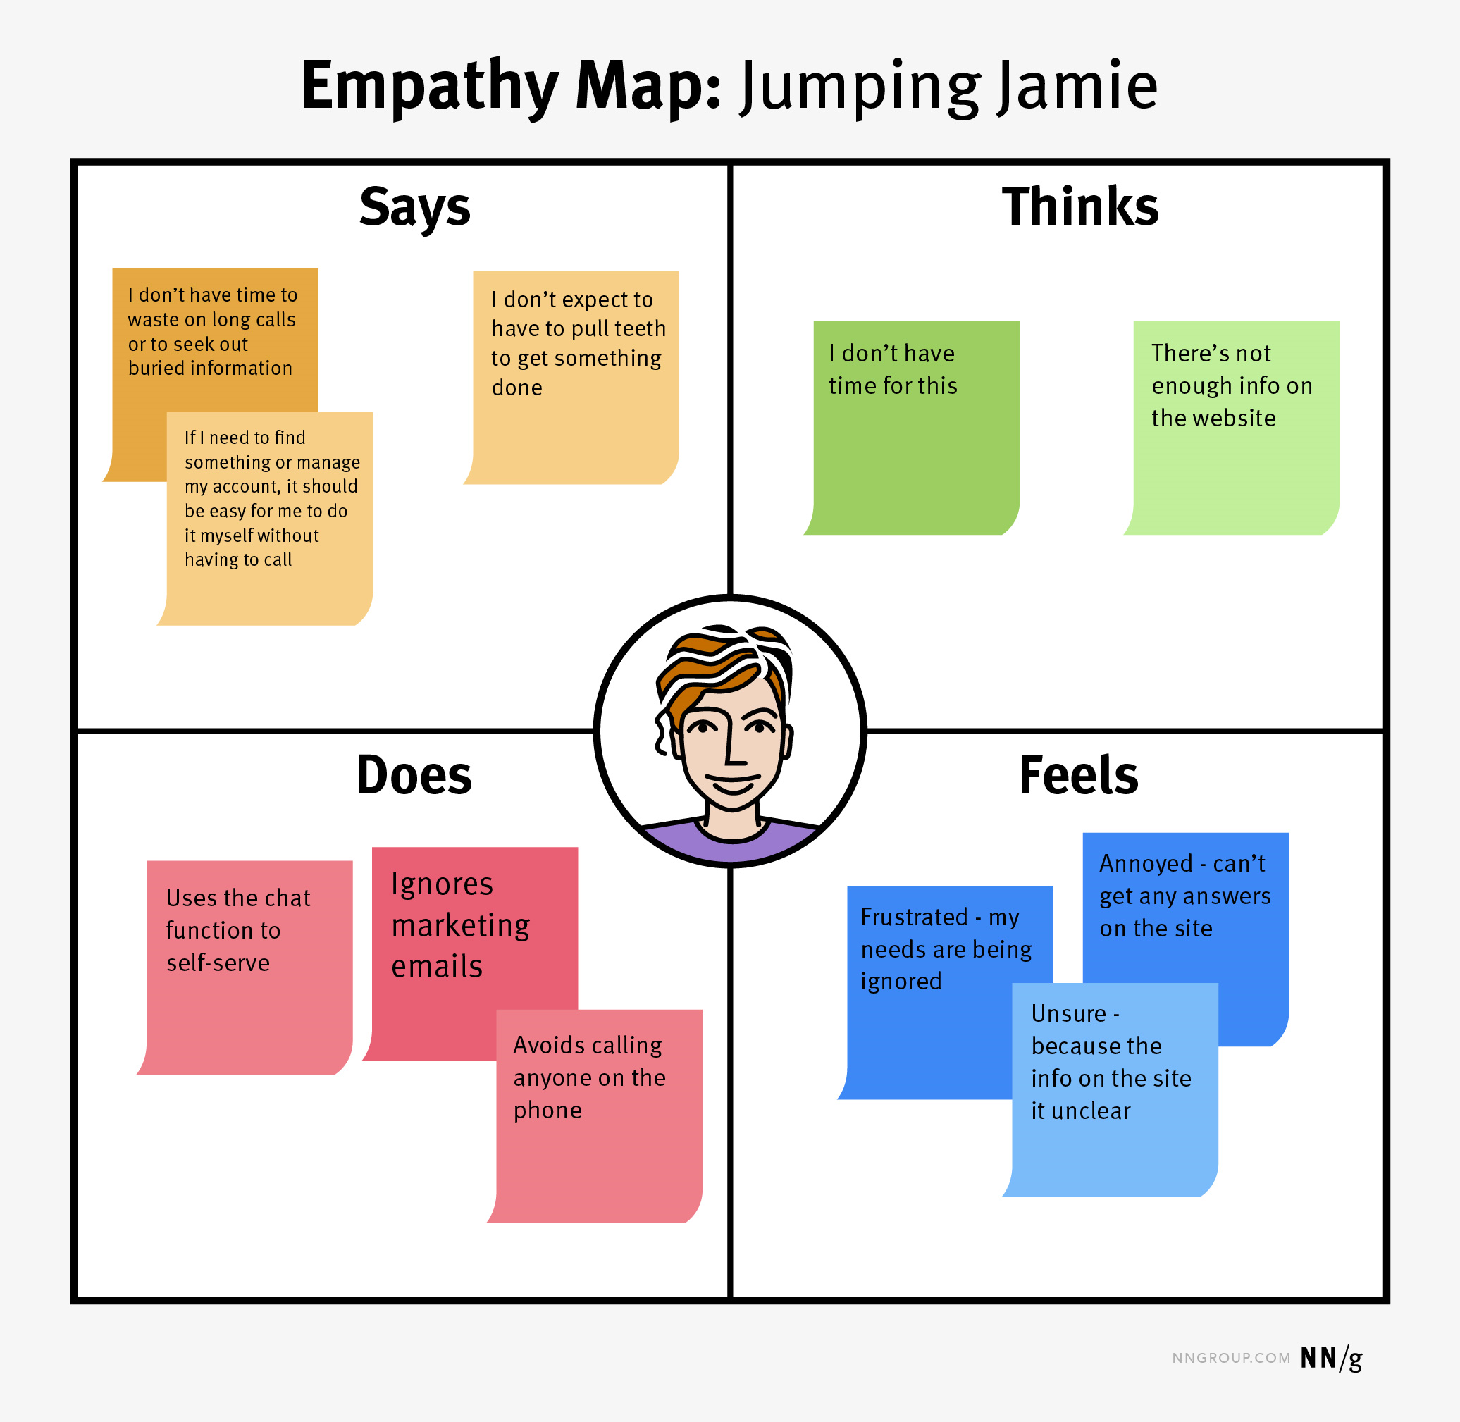

**BRINSTORMING**

Before you start writing, generate ideas through brainstorming techniques such as freewriting, listing, clustering or mapping. Then, go through the ideas you've come up with to determine which ones are useful and relevant and which ones you could do without.

**How to brainstorm**

Brainstorming is a problem-solving method for generating creative ideas in a group setting. In other words, it’s a chance for everyone to get creative, throw ideas at the wall, and see what sticks.

The rules are simple:

* Don’t criticize any ideas.
* Encourage a wide variety of ideas.
* Build on each other’s ideas.
* Don’t be afraid to share unrealistic or unconventional ideas.

The goal is to create a judgment-free space for everyone to participate so that innovation can thrive.

Group brainstorming stimulates creativity and invites participation from everyone, making it a great tool for generating a wide variety of ideas in a short amount of time. It’s especially helpful when trying to solve a problem that you are really close to. Sometimes getting outside perspectives can breathe new life into a project and drive momentum towards a solution